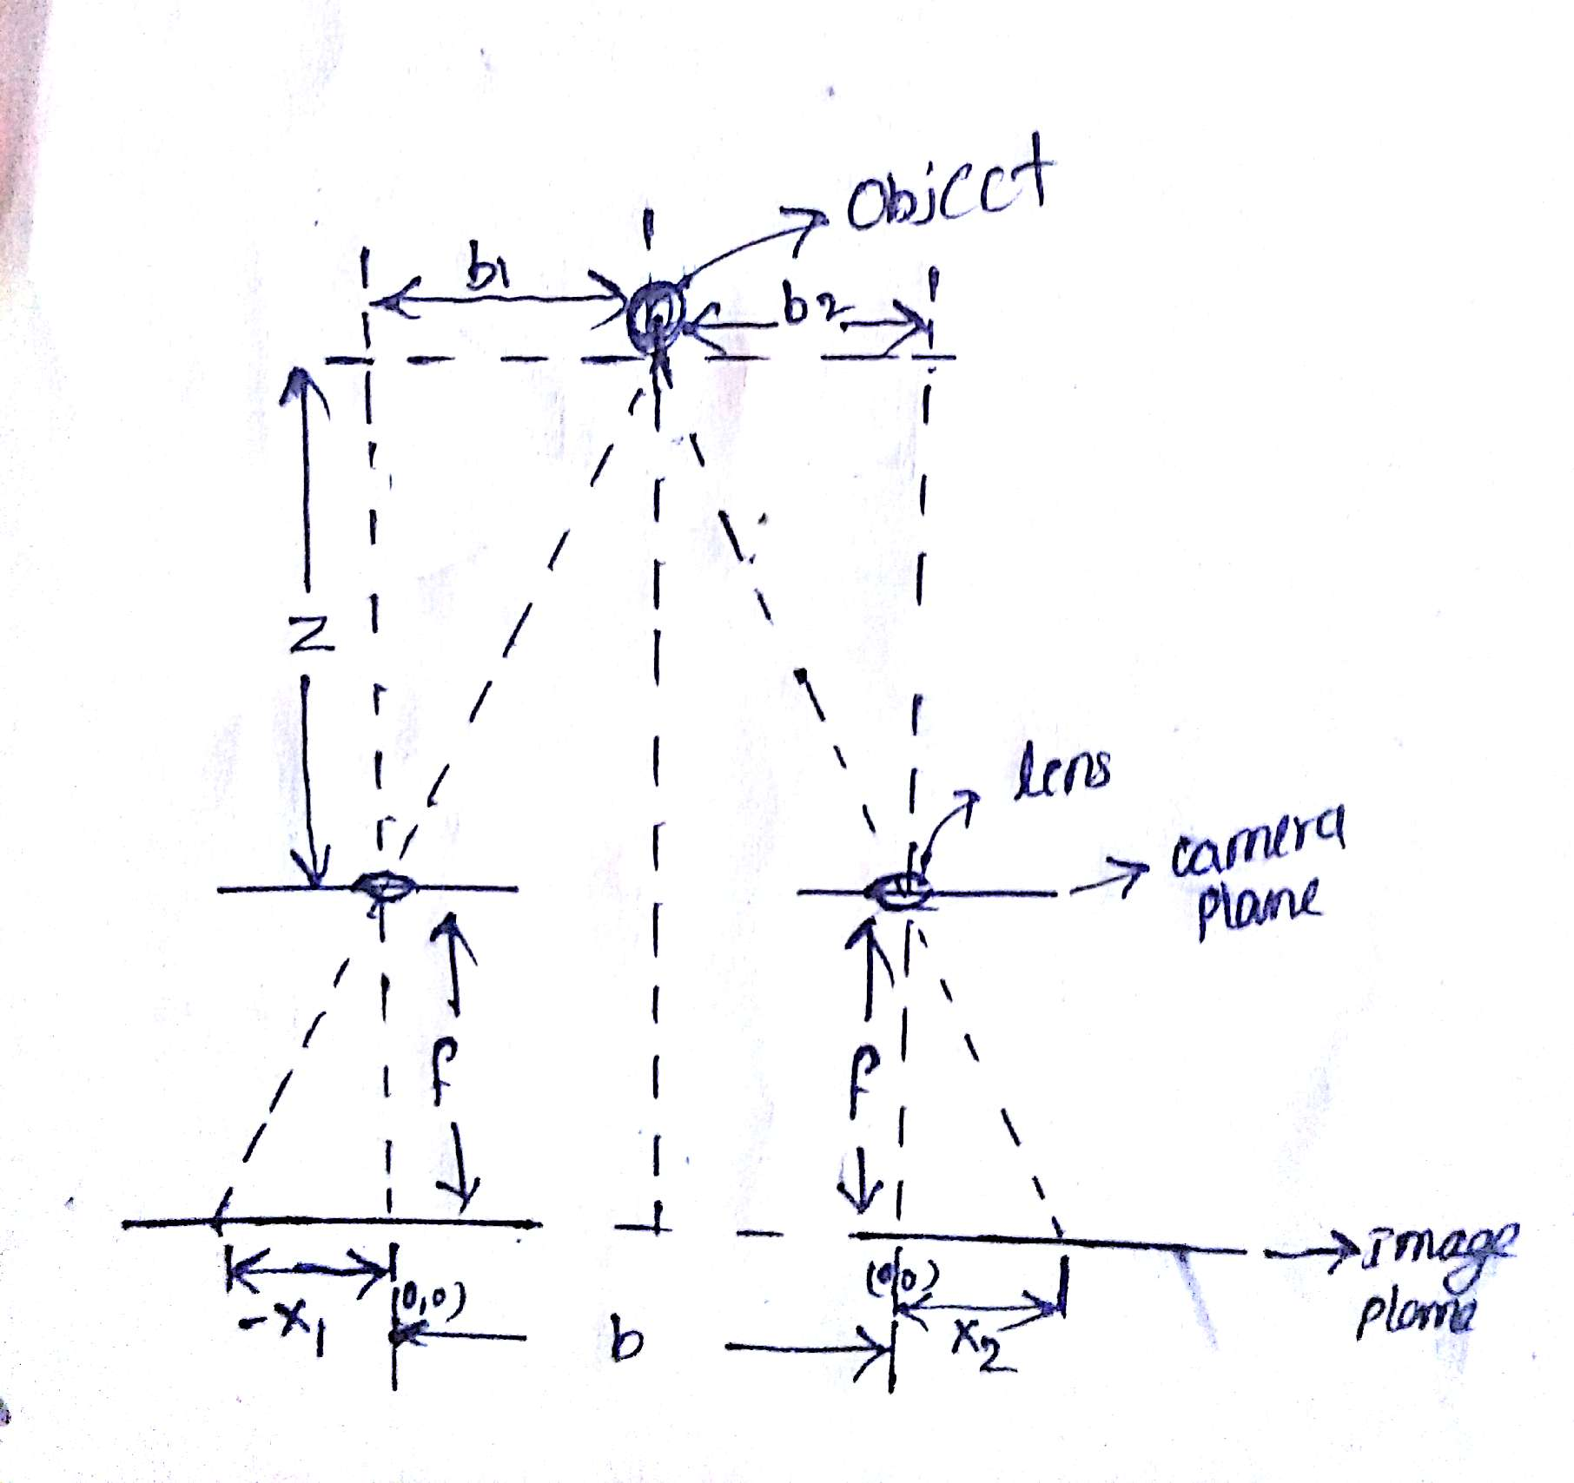
Stereo vision

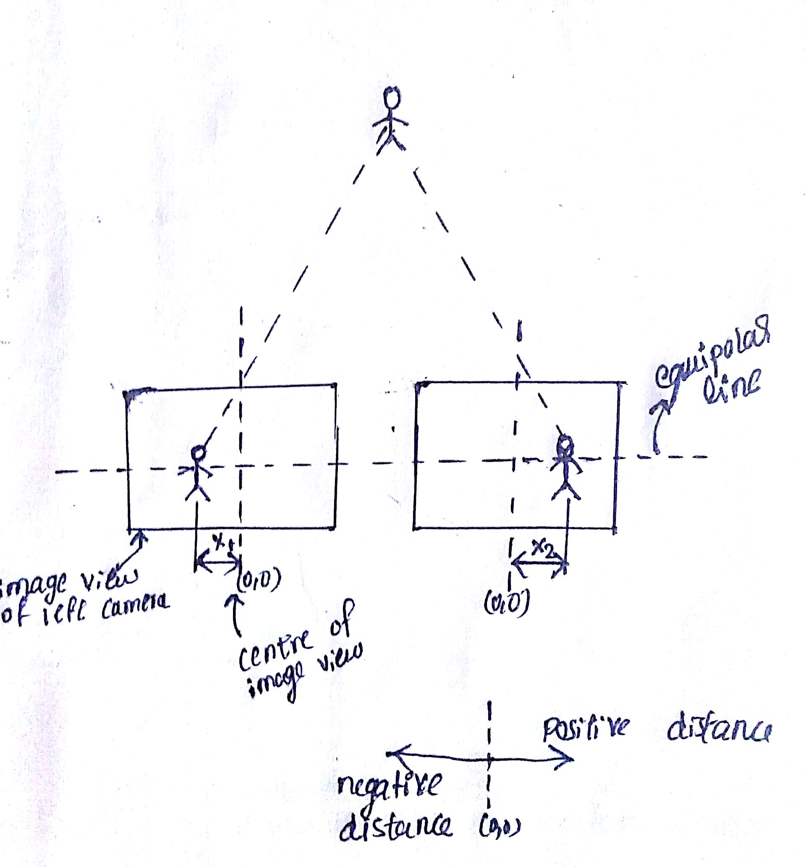

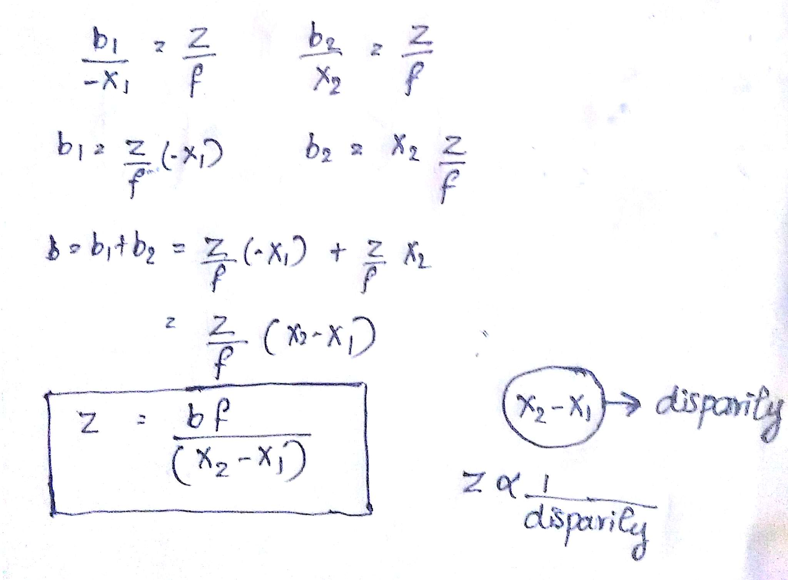

“Z” is the requied distance from the target object to the stereo camera system.Form the above equation it is clear that to determine the “Z” we need focal length(f) ,base distance between two cameras(b) and the disparity value(X2-X1).

Condition:
Cameras used for stereo vision should have same focal length and same field of vision.(Note: use same kind of cameras, if the cameras are different result may be wrong).

Steps:

2.To get focal length use the ROS based camera calibration method http://wiki.ros.org/camera_calibration/Tutorials/StereoCalibration

3.

